Let E be a simple solid region and let S be the boundary surface of E, given with positive (outward) orientation. Let F be a vector field whose component functions have continuous partial derivatives on an open region that contains E.

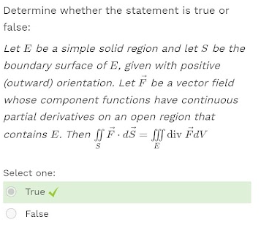

Determine whether the statement is true or false:

Is independent of path in D if and only if

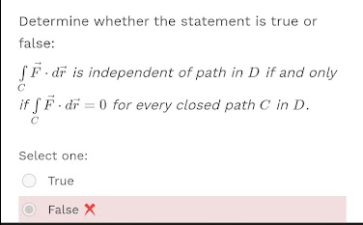

Determine whether the statement is true or false

If F and G are vector fields, then curl (F*G)

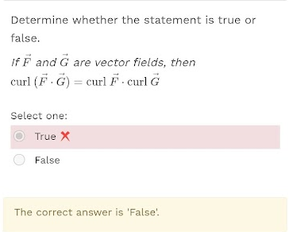

Determine whether the statement is true or false   
If F and G are vector fields, then curl (F+G)

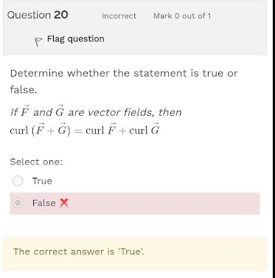

Determine whether the statement is true or false  
If f has continuous partial derivatives on R^3 and C is any circle

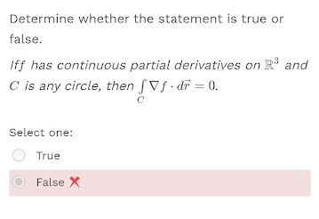

Let f be a scalar field. State whether the expression curl (grad f) is a scalar or a vector field. 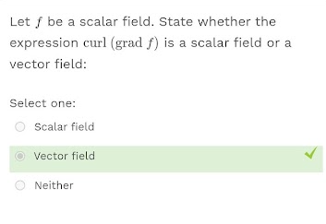

Determine whether the statement is true or false

Integral -c

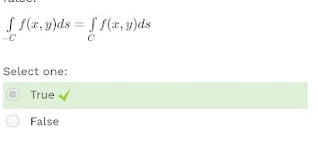

If F=Pi+Qj is a vector field on an open simply connected region D, where P and Q have continuous first-order derivatives

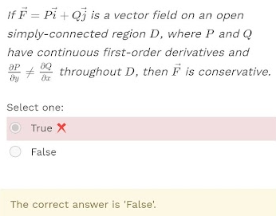

There is a vector field F such that curl F=yzi-xzj+xyk

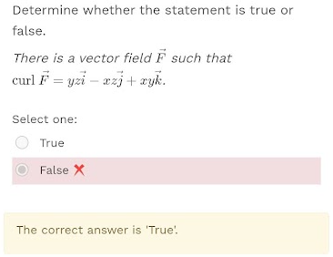

Assuming that the appropriate partial derivatives exist and are continuous, determine whether the statement is true or false:

If F, G are vector fields, then div

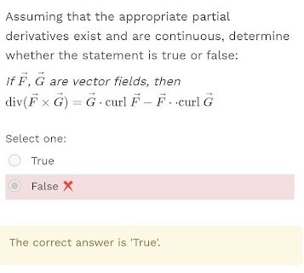

Let f be a scalar field and F a vector field. State whether the expression div(curl(grad f)) is meaningful

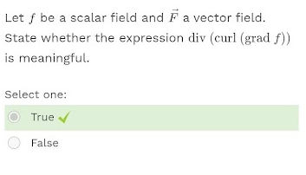

Suppose F(x,y) is a vector field that is P and Q have continuous first-order partial derivatives on an open connected region D.

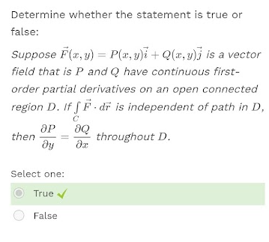

Assuming that the appropriate partial derivatives exist and are continuous, determine whether the statement is true or false.

If f is a scalar field and F is a vector field, then div(fF)

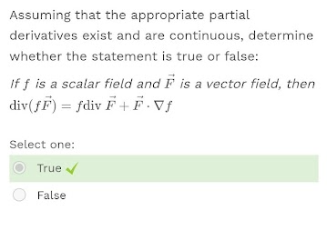is

Suppose F is a vector field that is continuous on an open connected region D.

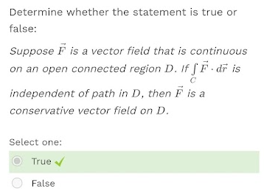

If F is a vector field, then curl F is a vector field

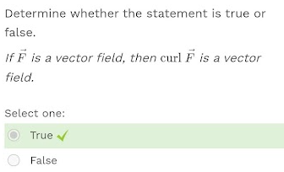

Let F a vector field. State whether the expression curl(curl F) is a scalar or a vector field.

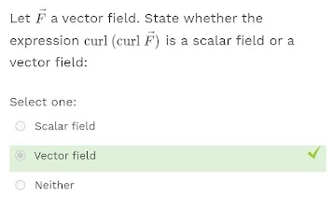

Let f be a scalar field and F a vector field. State whether the expression (grad f)*(div F) is meaningful

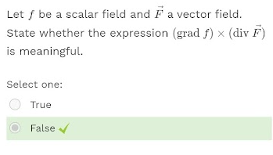

Let C be a positively oriented, piecewise-smooth, simple closed curve in the plane and let D be the region bounded by C. If P and Q have continuous partial derivatives on an open region that contains D then

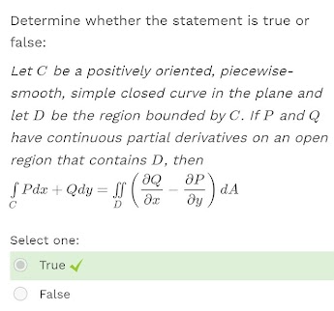

Let f be a scalar field. State whether the expression div(grad f) is a scalar field or a vector field.

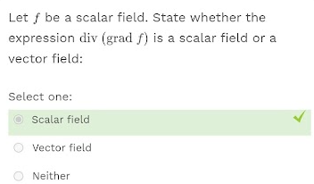

Let f be a scalar field and F a vector field. State whether the expression grad f is meaningful.

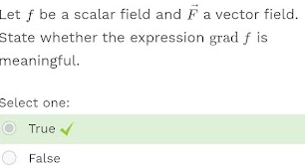

Assuming that the appropriate partial derivatives exist and are continuous, determine whether the statement is true or false

If f is a scalar field and F is a vector field, then curl (fF)=

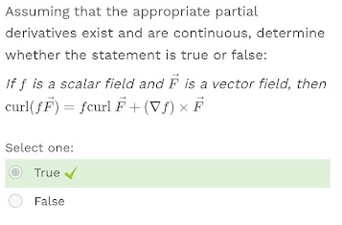

Let f be a scalar field and F a vector field. State whether the expression grad (div F) is meaningful

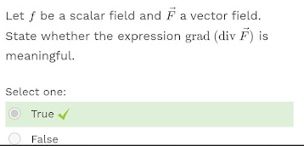

There is a vector field F such that curl F=xsinyi+cosyj+(z-xy)k

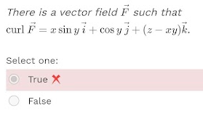

Let F a vector field. State whether the expression grad (div F) is a scalar field or a vector field

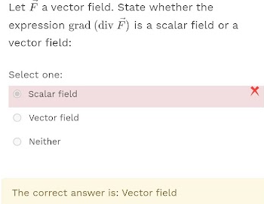

If F=Pi+Qj and Py=Qx in an open region D, then F is conservative

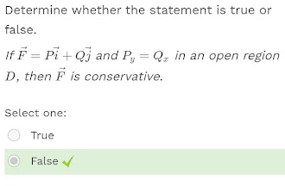

let f be a scalar field. state whether the expression grad f is a scalar field or a vector field

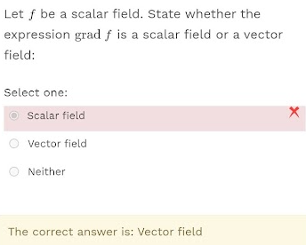

If f is a function of three variables that has continuous second-order partial derivatives, then curl=0

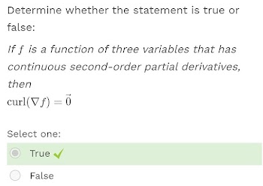

Let f be a scalar field and F a vector field. State whether the expression div (div F) is meaningful

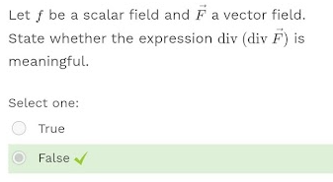

If F is a vector field defined on all of R^3 whose component functions have continuous partial derivatives and curl F=0, then F is a conservative vector field

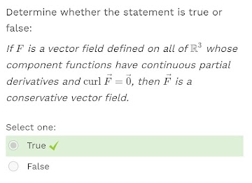

Assuming that the appropriate partial derivatives exist and are continuous, determine whether the statement is true or false

If f, g are scalars fields, then div (deltaf*deltag)=0

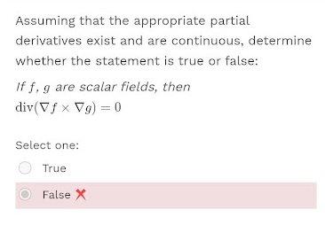

Determine whether the statement is true or false

If f has continuous partial derivatives of all orders on R^3, then div (curldeltaf)=0

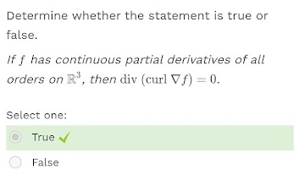

If F is a vector field, then div F is a vector field

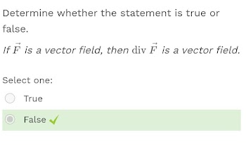

Let f be a scalar field and F a vector field. State whether the expression div F is meaningful

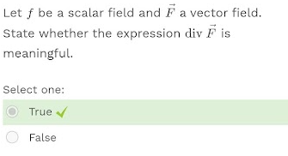

If F and G are vector fields and div F= div G, then F=G

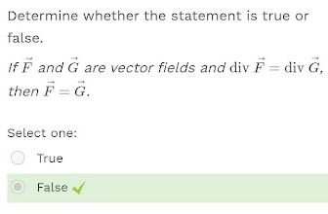

There is a vector field F such that curl F=2yi-4xzj+2xk

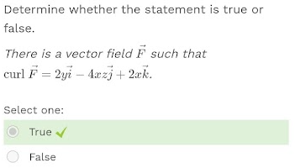

Let f be a scalar field and F a vector field. State whether the expression grad (div f) is meaningful

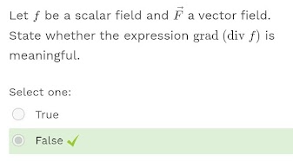

Assuming that the appropriate partial derivatives exist and are continuous, determine whether the statement is true or false

If F is a vector field, then curl(curl F)=grad(div F)-delta^2F

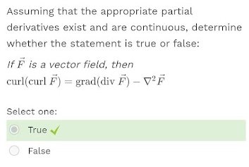

Let f be a scalar field. State whether the expression div (grad f) is a scalar field or a vector field.

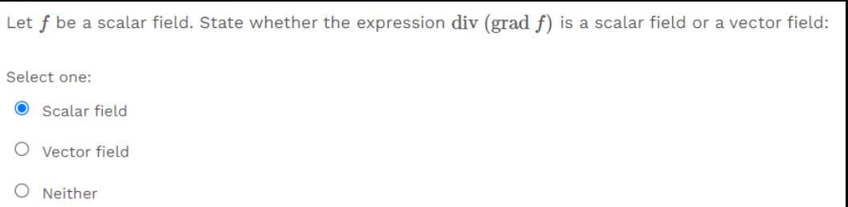

Let S be an oriented piecewise-smooth surface that is bounded by a simple, closed, piecewise-smooth

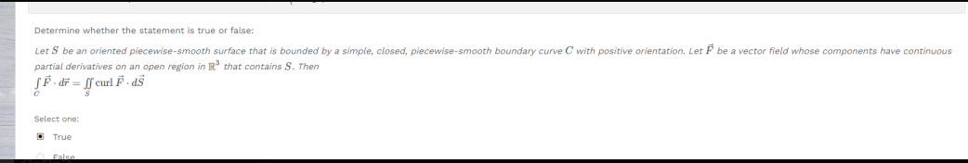

Is a conservative vector field, where P and Q have continuous first-order partial derivatives 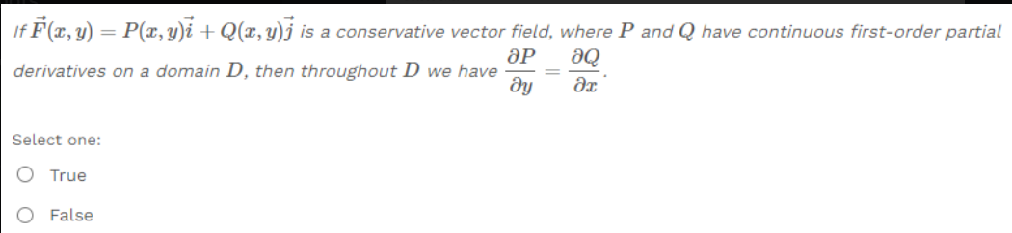

There is a vector field F such that curl F=xi+yj+zk . **False**

